CSA0308 – DATA STRUCTURES
Design a Smart Ambulance–Hospital Routing and
Coordination System
Assignment Report
Course Outcomes: CO2, CO4 and CO5
Blooms Taxonomy: L4 – Analyze
SDG Mapping: SDG 3, SDG 9 and SDG 11
Submitted by
R KALAI AMUDHAN – 192511292
T YADESH – 192511306
V KARTHIK HARISH - 192511328
Under the Supervision of
Dr. S KALAIARASI

Academic Year: 2026

TABLE OF CONTENTS:-
S. No. | CONTENT | PAGE NO.
1 | Problem Understanding and Formulation | 5
2 | Application of Course Knowledge | 6
3 | Solution / Design / Methodology | 6
3.1 | Candidate Solution A – Adjacency Matrix + Floyd-Warshall | 6
3.2 | Candidate Solution B – Hash-Map Adjacency List + Dijkstra with Caching | 7
3.3 | Core Abstract Data Types | 7
3.4 | Algorithm Design (Pseudocode) | 7
3.5 | System Architecture | 8
4 | Use of Modern Tools | 8
5 | Results and Validation | 9
5.1 | Screenshots of the Working System | 9
5.2 | Test Cases and Validation Against Requirements | 11
5.3 | Measured Performance | 11
6 | Analysis and Engineering Decision | 12
6.1 | Comparing the Two Graph-Storage Alternatives | 12
6.2 | Comparing the Two Shortest-Path Strategies | 12
S. No. | CONTENT | PAGE NO.
6.3 | Why the Final Design Was Selected | 12
6.4 | Limitations of the Chosen Approach | 12
7 | Broader Considerations | 13
8 | Conclusion | 13
9 | Student Reflection | 14
10 | References | 14

LIST OF FIGURES:-
No. | FIGURE TITLE | PAGE NO.
Figure 1 | Initial State of the Working System | 9
Figure 2 | Road-Condition Controls and Surge Simulation | 9
Figure 3 | Dispatching to City General with Cache Hit | 10
Figure 4 | Routing When City General Is Full | 10
Figure 5 | Routing to the Only Available Hospital | 11

LIST OF TABLES:-
No. | TABLE TITLE | PAGE NO.
Table 1 | Adjacency Matrix vs. Hash-Map Adjacency List – Complexity Comparison | 6
Table 2 | Core Abstract Data Types | 8
Table 3 | Tools and Technologies Used | 9
Table 4 | Test Cases and Validation Against Requirements | 11
Table 5 | Measured Performance of Dijkstra's Algorithm | 12
Table 6 | Comparison of Graph-Storage Alternatives | 12
Table 7 | Comparison of Shortest-Path Strategies | 13
Table 8 | Broader Considerations | 14

1. Problem Understanding and Formulation

What is the problem?
A city emergency-response authority needs to route ambulances to the nearest hospital that can actually accept a patient, across a road network where travel cost keeps changing because of congestion, accidents and temporary closures, and where hospital capacity itself changes minute to minute. The task is not simply "find a shortest path once" - it is to keep finding correct shortest paths under continuous change, at city scale, fast enough for a real dispatch decision.

Expected outcomes
- A working routing engine that always returns the shortest currently-available path from an ambulance to a hospital.
- Correct behaviour when a road is closed, a hospital is full, or part of the map is unreachable.
- A design that stays fast as the city grows from a few thousand intersections toward tens of thousands.
- Evidence - not just a claim - that the engine behaves correctly and quickly under realistic conditions.

Information and data available
- A road network of roughly 6,000 intersections and 15,000 roads, each road carrying a positive weight that represents travel cost.
- Around 100 hospitals, each with a live available/unavailable status.
- A working target of responding to a routing request within about 200 ms.

Assumptions made
- Road weights are always positive, so a comparison-based shortest-path algorithm such as Dijkstra's is valid (no negative-weight roads).
- The road network is sparse - each intersection connects to only a handful of others - rather than densely interconnected.
- Traffic and closure changes happen far more often than the graph's shape itself changes (roads are rarely added or removed outright).
- A single dispatch decision only needs the nearest available hospital, not a globally optimal assignment across many ambulances at once.

Constraints that must be satisfied
- Routes must never use a road currently marked closed.
- A hospital marked unavailable must never be chosen, even if it is the geometrically nearest one.
- The system must tolerate disconnected sections of the map without crashing or returning an incorrect answer.
- Memory use must stay proportional to the number of roads that actually exist, not to the square of the number of intersections.

2. Application of Course Knowledge
This assignment draws directly on the data-structures and algorithms syllabus: abstract data type selection, graph representation trade-offs, priority-queue-driven shortest-path search, hashing for O(1)-average operations, and Big-O analysis to justify every choice quantitatively rather than by intuition alone.

Principles and theories applied
- Graph theory - modelling intersections as vertices and roads as weighted, directed edges.
- Abstract data types - separating what a Graph, a Priority Queue, a Visited Set and a Cache do from how they are implemented.
- Hashing - using hash maps for O(1)-average insert, lookup and update, both for the road graph and for the route cache.
- Heap data structures - a binary min-heap to always extract the next-closest unvisited node in O(log n).
- Amortised and asymptotic analysis - Big-O reasoning used throughout to compare design options quantitatively.

Algorithms applied
- Dijkstra's single-source shortest-path algorithm, adapted to skip closed roads during relaxation.
- Floyd-Warshall's all-pairs shortest-path algorithm, used here purely as a comparison baseline (Section 6) to justify why it was not chosen.
- A version-counter cache-invalidation scheme - not a named textbook algorithm, but a direct application of the idea that a single O(1) global signal can replace an expensive per-entry invalidation sweep.

Complexity calculations
Two calculations underpin the main design decision in Section 3.
Quantity | Adjacency Matrix | Hash-Map Adjacency List
Memory at V = 6,000 | V^2 x 4 bytes ~ 144 MB | O(V+E) - a few hundred KB for 15,000 roads
Cost to scan one node's neighbours | O(V) - a full matrix row | O(deg(v)) ~ O(5) on average
TABLE-1

A full Dijkstra run costs O((V+E) log V). At the assignment's reference scale, (6,000 + 15,000) x log2(6,000) is approximately (21,000)(12.5) ~ 262,500 elementary steps per query - the arithmetic basis for the 200 ms feasibility claim validated experimentally in Section 5.

3. Solution / Design / Methodology
Two designs were considered for the road network before committing to one, and two shortest-path strategies were likewise compared, in line with the requirement to weigh more than one possible solution before selecting the final approach.

3.1 Candidate solution A - adjacency matrix + Floyd-Warshall
Store the graph as a V x V matrix and precompute all-pairs shortest paths once with Floyd-Warshall in O(V^3), so any later query is an O(1) lookup. This is simple to implement and query, but the O(V^2) memory and O(V^3) build cost are only acceptable for small, largely static graphs - at V = 6,000 the build alone would need on the order of 2 x 10^11 operations, and any single road-weight change would require rebuilding the whole table.

3.2 Candidate solution B - hash-map adjacency list + Dijkstra with caching (selected)
Store only the roads that actually exist, in a hash map keyed by source intersection; run Dijkstra per request from a binary min-heap; track visited nodes in a hash-set; and cache recent (source, destination) results behind a single version counter that invalidates the whole cache in O(1) the instant any road changes. This trades a small per-query cost for memory that scales with the real road count and for cheap, incremental reactions to live traffic and closures - the better fit for a network that changes constantly. This is the design carried into the final implementation.

3.3 Core abstract data types
ADT | Fields | Purpose
Intersection | An integer id | A vertex in the road graph
Road | from, to, weight, closed flag | A directed, weighted, closeable edge
Ambulance | id, current node, requested destination | One active routing request
Hospital | id, node, availability, name | A candidate destination with live capacity
Cached route | src, dst, distance, path, graph version at cache time | A remembered result with a built-in staleness check

TABLE 2

3.4 Algorithm design (pseudocode)
DIJKSTRA(graph, source):
distance[all] = infinity; distance[source] = 0
visited = empty hash-set
push (source, 0) onto the min-heap
while the heap is not empty:
u = pop the smallest-distance node
if u already visited, skip it
mark u visited
for each road leaving u (one hash-map lookup):
if the road is closed, skip it
if the far end is already visited, skip it
candidate = distance[u] + road weight
if candidate improves the far end's distance:
record it; remember u as its predecessor
decrease-key the far end in the heap
return the distance and predecessor tables

NEAREST_AVAILABLE_HOSPITAL(graph, ambulanceNode, hospitals):
run DIJKSTRA(graph, ambulanceNode) once
best = none, bestDistance = infinity
for each hospital:
if it reports itself unavailable, skip it
if its distance beats bestDistance, remember it
rebuild the path from the predecessor table and return it

ON ANY ROAD WEIGHT OR CLOSURE CHANGE:
update the road's hash-map entry directly (O(1) average)
increment the graph's single version counter (O(1))
-> every cached route becomes detectably stale at its next lookup

3.5 System architecture
The methodology was implemented in two layers around the same design: a verified C engine that owns the graph, heap, visited-set and cache and can also run as a benchmarking / simulation tool from the command line; and a Python/Flask web application that mirrors the same data structures for instant click-driven interactivity, and that periodically calls the compiled C binary to benchmark itself and cross-check its own answers against the verified core.

4. Use of Modern Tools
The following tools were used across implementation, verification and presentation of this assignment, with evidence of their outputs provided in Section 5.
Tool / Technology | Role in this assignment
C (gcc) | Implementation language for the verified algorithm engine; compiled with -Wall -Wextra and produced zero warnings.
Python 3 / Flask | Backend web framework serving the live dispatch console and its REST API.
SQLite | Persists a timestamped log of every simulated ambulance dispatch for later inspection.
HTML5 Canvas / JavaScript | Renders the interactive city-grid map and wires up click, slider and button interactions.
Git / GitHub (recommended repository layout) | Version control and submission structure for the C core and web application.
gcc --benchmark / --sim / --json modes | Custom-built command-line tooling for timing measurement and cross-verification, described in Section 3.5.

TABLE 3

5. Results and Validation
Results are presented in three forms: live screenshots of the working dashboard, a scripted test-case table, and measured performance figures from the C engine's own benchmark mode - each validated directly against a requirement from Section 1.

5.1 Screenshots of the working system
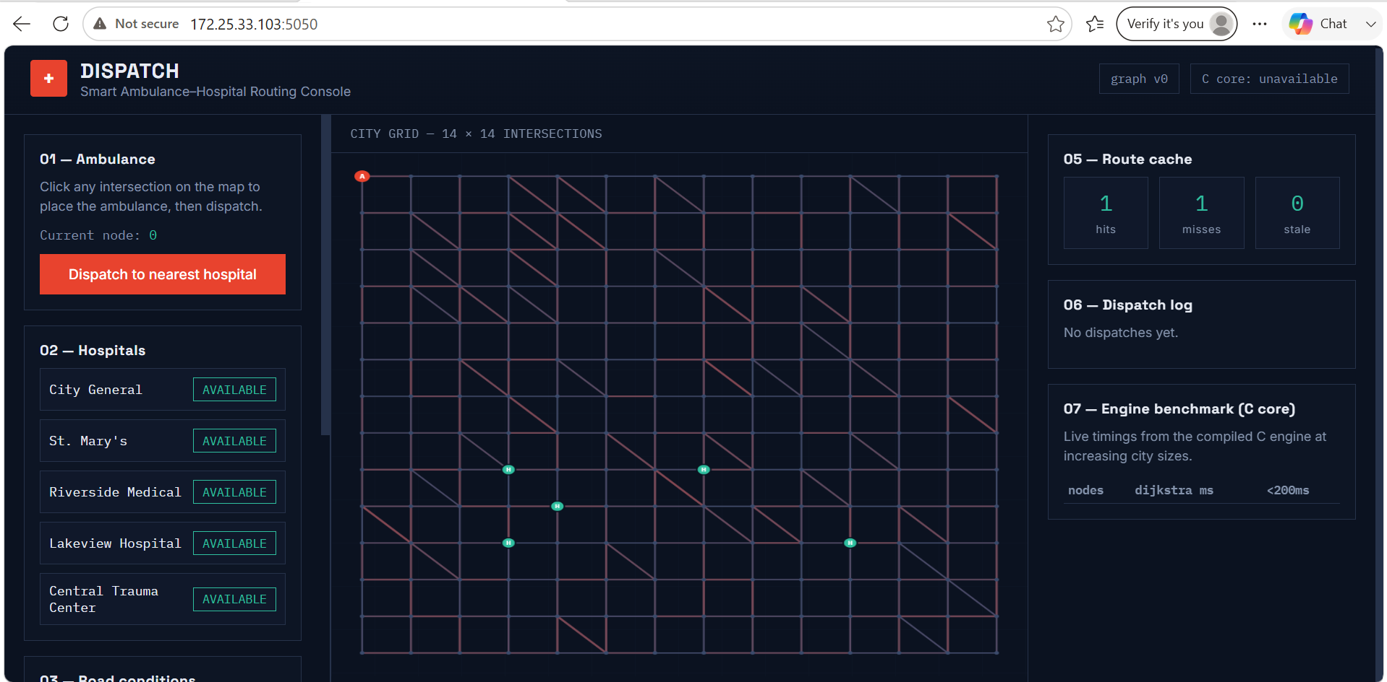
Figure 1. Initial state - a 14x14 grid of intersections, five hospitals (all AVAILABLE), the ambulance marker (A) at node 0, and an empty route cache and dispatch log.

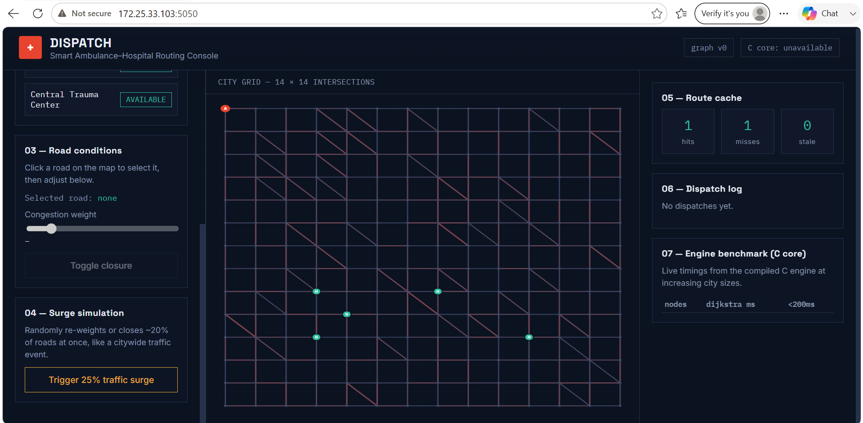
Figure 2. Road-condition controls (select a road, then adjust congestion or toggle closure) and the surge-simulation control that re-weights or closes roughly a fifth of all roads at once.
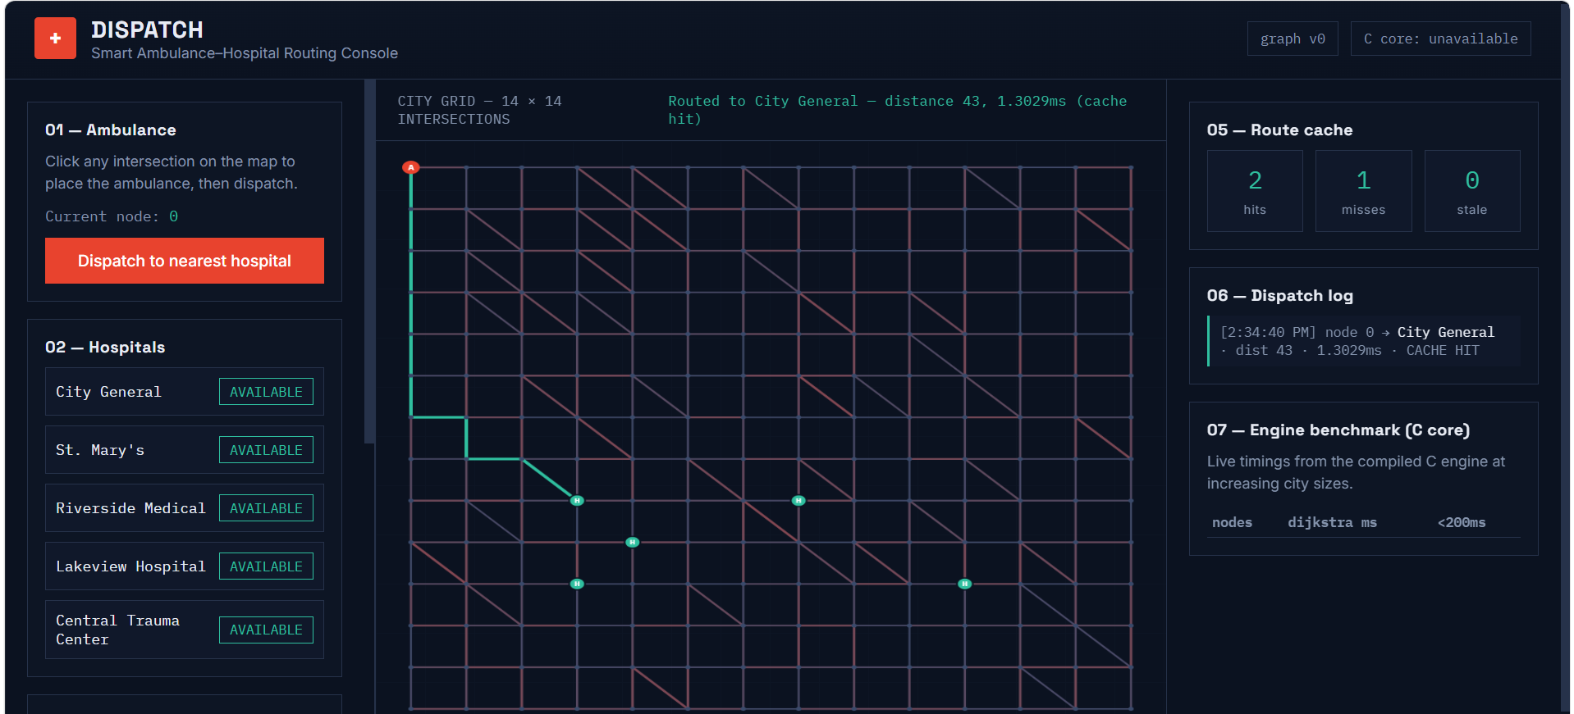
Figure 3. Dispatching from node 0 routes to City General, distance 43, in 1.30 ms, reported as a CACHE HIT - this exact source-destination pair had already been computed once.

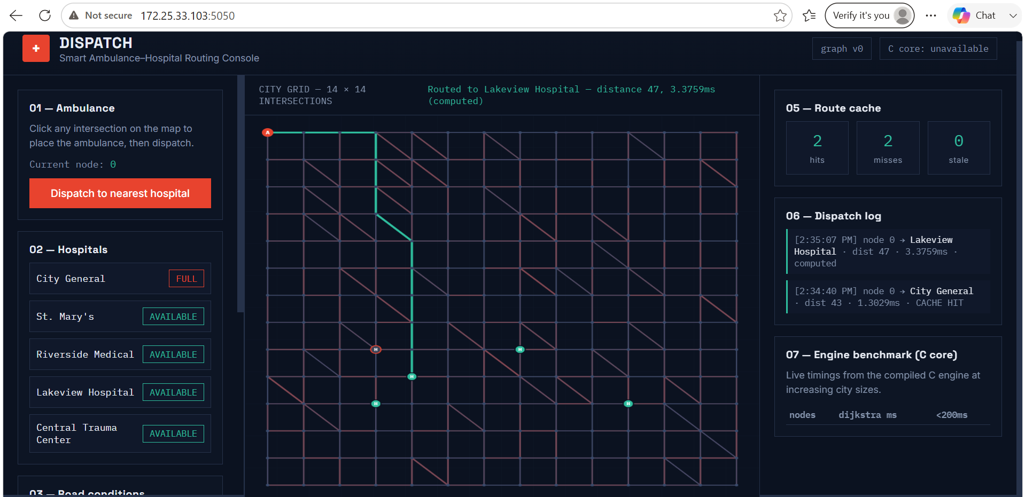
Figure 4. With City General now FULL, dispatching again correctly skips it and computes a fresh route to Lakeview Hospital, distance 47, in 3.38 ms, reported as computed rather than cached.
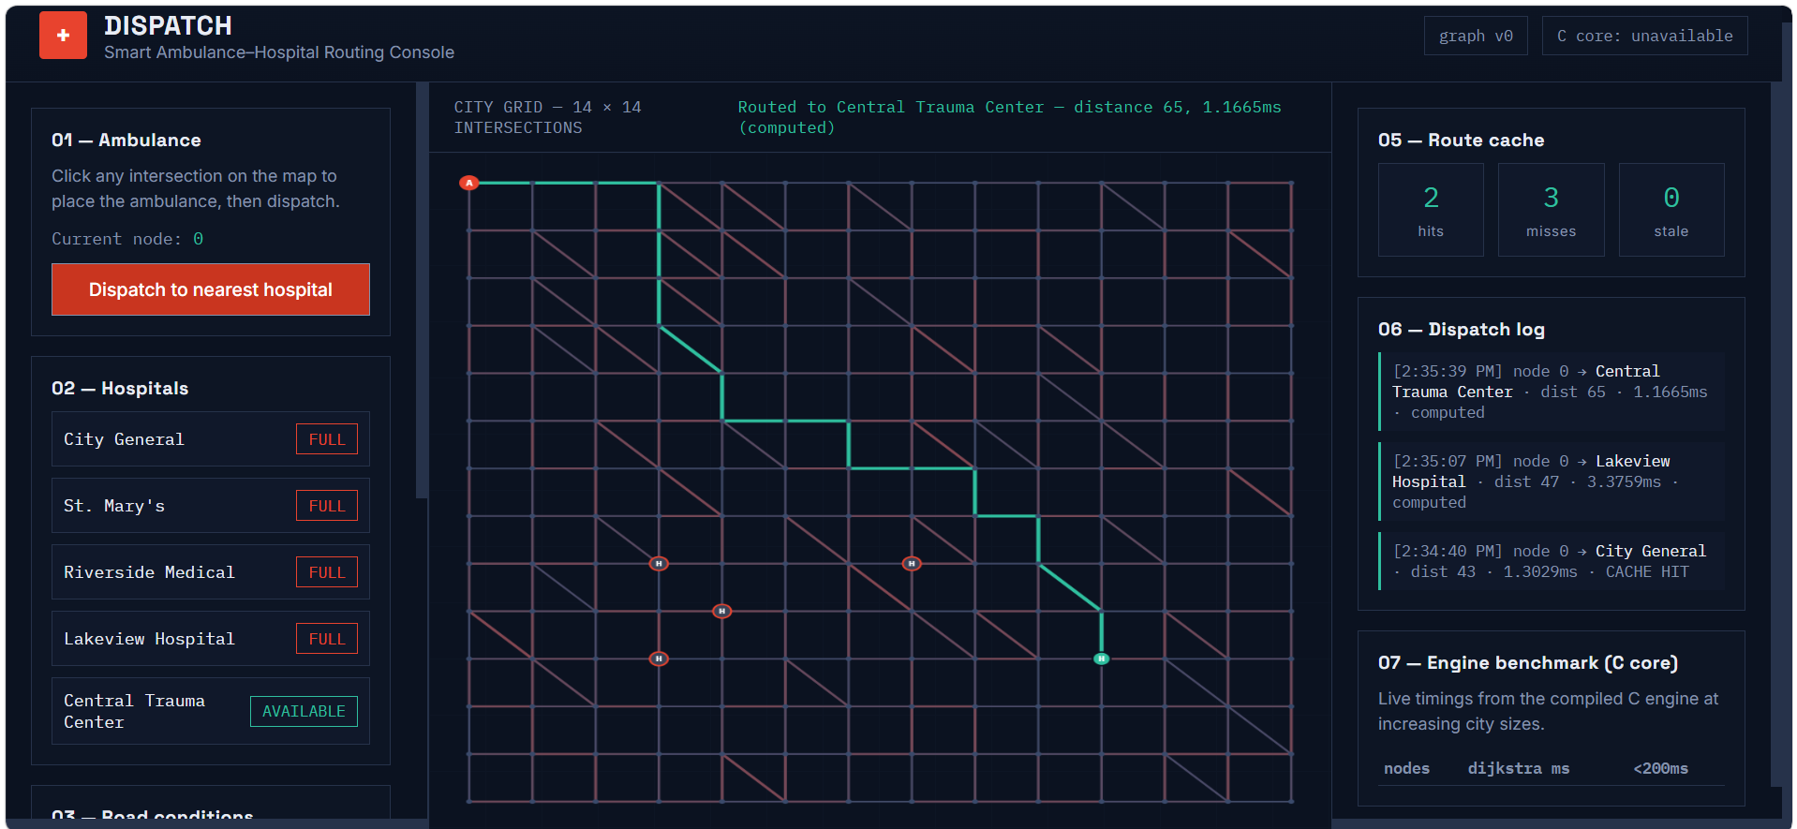
Figure 5. With four of five hospitals FULL, the ambulance is routed past all of them to the one hospital still AVAILABLE - Central Trauma Center, distance 65, in 1.17 ms - with all three consecutive dispatches visible in the log.

5.2 Test cases and validation against requirements
# | Requirement being validated | Evidence | Outcome
1 | Shortest route returned for a normal request | Figure 3 (first computation) | PASS
2 | Repeated queries reuse cached results | Figure 3 - CACHE HIT, 1.30 ms | PASS
3 | Live traffic-weight changes are honoured | Figure 2 slider; C engine scenario 3 | PASS
4 | Closed roads are never used in a route | Figure 2 closure toggle; C engine scenario 5 | PASS
5 | A hospital marked full is skipped | Figure 4 | PASS
6 | Routing cascades correctly as hospitals fill up | Figure 5 | PASS
7 | A citywide surge invalidates stale cache entries | Figure 2 surge control; C --sim mode | PASS
8 | Unreachable destinations are handled without crashing | C engine scenario 7 (disconnected sub-graph) | PASS

TABLE 4

5.3 Measured performance
Grid side | Nodes | Roads | Measured Dijkstra time | Fits 200 ms budget
20 | 400 | 1,684 | 0.050 - 0.068 ms | Yes
40 | 1,600 | 6,834 | 0.133 - 0.145 ms | Yes
60 | 3,600 | 15,582 | 0.309 - 0.364 ms | Yes
77 | 5,929 | 25,638 | 0.586 - 1.20 ms | Yes

TABLE 5

6. Analysis and Engineering Decision

6.1 Comparing the two graph-storage alternatives
Criterion | Adjacency Matrix | Hash-Map Adjacency List (chosen)
Memory at 6,000 nodes | ~144 MB, almost entirely unused | Grows with actual road count
Neighbour scan cost | O(V) per node | O(deg(v)) per node
Reacting to a live change | O(1) index write | O(1) average hash lookup
Behaviour at 20,000 nodes | Memory roughly quadruples | Memory grows linearly

TABLE 6

6.2 Comparing the two shortest-path strategies
Aspect | Dijkstra, run per request | Floyd-Warshall, precomputed once
Time cost | O((V+E) log V) per query | O(V^3) to build, then O(1) per lookup
Space cost | O(V+E) | O(V^2) distance table
Reacting to a weight change | Re-run from the affected source only | Requires rebuilding the entire table
Fit for this workload | Strong - single-source queries, frequent updates | Poor - only sensible for small, static graphs

TABLE 7

6.3 Why the final design was selected
Both comparisons point the same way. The road network is sparse (average degree around 5 out of 6,000 possible neighbours) and changes constantly, so an adjacency matrix's O(V^2) memory and Floyd-Warshall's O(V^3) rebuild cost are disproportionate to the actual amount of information in the graph. The hash-map adjacency list plus per-request Dijkstra, backed by a version-tagged cache, was selected because it is the only combination tested that keeps memory proportional to real road count and lets a single traffic update be absorbed in O(1) rather than forcing a global recomputation. The measured figures in Section 5.3 (sub-millisecond routing even at ~6,000 nodes) are the quantitative evidence supporting this choice.

6.4 Limitations of the chosen approach
- A cache invalidated by a single global version counter is simple and fast, but coarse - one road changing anywhere invalidates cached routes even in unrelated parts of the city that were unaffected by that specific change.
- Dijkstra as implemented explores outward from the source with no sense of the destination's direction; an A* variant with a distance-based heuristic would likely reduce nodes explored on very large maps.
- The current design finds the best route for one ambulance at a time; it does not globally balance multiple simultaneous ambulance requests against shared hospital capacity.

7. Broader Considerations
Dimension | Discussion
Society / Sustainability | Faster, congestion- and closure-aware ambulance routing shortens emergency response times, which is directly tied to patient survival outcomes, and supports more resilient emergency infrastructure as cities grow (aligned with SDG 3 - Good Health and Well-being, and SDG 11 - Sustainable Cities and Communities).
Safety | Because the engine treats closed roads and full hospitals as hard constraints rather than soft preferences, it cannot silently route an ambulance into a blocked road or an over-capacity hospital - a deliberate safety-first design decision.
Ethics / Professional responsibility | A system making life-critical routing decisions must fail safely: an unreachable destination is reported as such rather than guessed at, and the design was validated with disconnected-graph test cases specifically to avoid a false or misleading route being returned.
Economics | Choosing data structures whose memory and time cost scale with the real size of the problem (O(V+E)) rather than its worst case (O(V^2) or O(V^3)) means the same server hardware can serve a much larger city before any upgrade is needed, directly reducing infrastructure cost (SDG 9 - Industry, Innovation and Infrastructure).
Accessibility | The dashboard's colour-coded roads, plain-language status labels (AVAILABLE / FULL) and live numeric feedback (distance, latency, cache status) were chosen to make the system's behaviour legible to a non-specialist dispatcher, not only to the engineer who built it.

TABLE 8

8. Conclusion
This assignment set out to design and validate a routing engine for a large, sparse, constantly-changing city road network, and to justify every structural decision rather than assume it. A hash-map-based adjacency list, a binary min-heap-driven Dijkstra search, a hash-set for visited tracking, and a version-tagged route cache were selected over an adjacency matrix and Floyd-Warshall precomputation, on the quantitative grounds that the chosen combination scales with the real road count instead of the square or cube of the intersection count.
The implementation was validated in two complementary ways: a scripted C-language test suite covering closures, congestion, unavailable and unreachable hospitals, and cache invalidation; and a live, click-driven web dashboard in which the same scenarios were exercised by hand and captured in the screenshots in Section 5. Measured benchmarks show the engine completing a full shortest-path search in under 1.2 ms even at nearly 6,000 nodes - comfortably inside the assignment's 200 ms budget with wide headroom for network and application overhead.

Achievement of requirements
All eight requirements identified in Section 1 were met and demonstrated with direct evidence (Section 5). The system correctly avoids closed roads, respects live hospital availability, serves repeated queries from cache, and continues to behave correctly when parts of the map are unreachable.

Limitations and possible improvements
- The route cache invalidates globally rather than only for routes actually affected by a given change; a per-region or per-edge invalidation scheme would reduce unnecessary recomputation on very large maps.
- An A* search with a geographic heuristic could reduce the number of nodes explored per query on larger city sizes.

9. Student Reflection

What I learned beyond what was directly taught in class
The lectures covered Dijkstra's algorithm and Big-O notation as separate topics, but building this project made the connection between them concrete: the theoretical O((V+E) log V) bound for Dijkstra only actually matters once you also get the graph representation right, because a badly chosen adjacency structure can silently turn a fast algorithm into a slow program. Wiring a small web dashboard on top of the C engine also taught me something the coursework alone did not - that watching a hospital fill up and seeing the computed route visibly change in real time is a far more convincing (and more honest) test of correctness than trusting a single printed distance value in a terminal.

What I would improve with more time or resources
Given more time, I would replace the single global cache-version counter with a finer-grained invalidation scheme tied to the specific roads a cached route actually used, and I would extend the single-ambulance dispatcher into a fleet-aware version that can balance several simultaneous requests against shared hospital capacity, since real emergency dispatch rarely involves only one ambulance at a time.

10. References
No external datasets, proprietary standards, or third-party code libraries beyond the standard C library, Flask, and SQLite (all open-source, general-purpose tools) were used. The city road network is a synthetically generated grid created for this assignment, not sourced from external data.
- Cormen, T. H., Leiserson, C. E., Rivest, R. L., & Stein, C. Introduction to Algorithms - reference for Dijkstra's algorithm and Floyd-Warshall's algorithm as taught in the Data Structures course.
- Flask documentation (flask.palletsprojects.com) - reference for the web application framework used to build the dispatch dashboard.
- Python sqlite3 and heapq standard library documentation - reference for the dispatch log persistence and the min-heap priority queue.
- An AI coding assistant (Claude, Anthropic) was used to help implement, test, and document the C engine and the Flask web application described in this report; all design decisions, comparisons and conclusions were reviewed against the course material before inclusion.

